🧠 OBJECTIVE

🧩 Big Picture First: How Interviewers See You
At 4 years, they are not checking syntax.
They are checking:
- Can you design automation, not just write scripts?
- Do you understand Selenium internals, not just driver.findElement?
- Can you debug flaky tests and explain why something fails?
- Do you know when NOT to use Selenium?
Keep this lens while reading 👇

1️⃣ Selenium Core Architecture (You MUST be fluent)

What you should clearly explain:
- Selenium is not a testing tool, it is a browser automation library
- Selenium follows Client–Server architecture
- Java code → Selenium Client → W3C WebDriver Protocol → Browser Driver → Browser

Interview-ready explanation:
Selenium uses the W3C WebDriver protocol where client libraries (Java) send HTTP commands to browser-specific drivers (ChromeDriver, GeckoDriver), which then control the browser natively.

🔥 You must know:
- Why Selenium 4 removed JSON Wire Protocol
- Why browser drivers are mandatory
- Difference between Selenium 3 vs Selenium 4 architecture

2️⃣ WebDriver Interface & Browser Drivers (Depth Matters)

Concepts you must command:
- WebDriver is an interface, not a class
- ChromeDriver, FirefoxDriver are concrete implementations
- Why we code to interface, not implementation

Interview trap:
“Why do we write WebDriver driver = new ChromeDriver()?”
Correct angle:
- Loose coupling
- Browser switchability
- Better framework design

3️⃣ Locators: Not Syntax, STRATEGY 🧭

You must master:
- ID, Name (fastest)
- CSS Selector (preferred)
- XPath (powerful but dangerous if abused)

XPath depth expected:
- Absolute vs Relative XPath
- contains(), starts-with()
- Axes: parent, ancestor, following-sibling
- Dynamic XPath strategy

Interview gold:
XPath is a fallback strategy, not the first choice.

Real-world maturity:
- Avoid brittle locators
- Build resilient locators aligned with DOM behavior

4️⃣ Waits & Synchronization (This Separates Juniors from Seniors)

You must clearly differentiate:
Type | Scope | Why
Implicit Wait | Global | Legacy, risky
Explicit Wait | Conditional | Preferred
Fluent Wait | Polling control | Advanced

You must explain:
- Why Thread.sleep() is bad
- Polling interval vs timeout
- Ignoring exceptions in FluentWait

Interview scenario:
“Your test passes locally but fails in CI. Why?”
Expected thinking:
- Network latency
- Page rendering delays
- Improper wait strategy

5️⃣ WebElement Deep Understanding 🧠

You should know:
- findElement vs findElements
- NoSuchElementException vs StaleElementReferenceException
- Why stale elements happen (DOM refresh)

Advanced handling:
- Re-locating elements
- Using waits to avoid stale state
- When PageFactory fails

6️⃣ Page Object Model (NOT just a pattern)

What interviewers expect:
- Separation of test logic and page logic
- Reusability
- Maintainability

You must explain:
- Why POM reduces duplication
- Why PageFactory is optional
- Why locators should NOT be inside tests

Senior-level insight:
POM solves maintenance problems, not execution problems.

7️⃣ TestNG + Selenium (Execution Brain)

Must-know concepts:
- Annotations lifecycle
- @BeforeSuite, @BeforeClass, @BeforeMethod
- Assertions vs Verifications
- TestNG XML execution

Parallel execution:
- parallel="methods" vs tests
- Thread safety
- Why ThreadLocal<WebDriver> is needed
🔥 You already discussed ThreadLocal earlier — this is huge for your profile.

8️⃣ Selenium Grid & Parallel Execution 🌐

You must explain:
- Why Grid exists
- Hub–Node concept (Selenium 3)
- Distributed execution (Selenium 4)

Interview-level clarity:
Selenium Grid enables cross-browser and parallel execution by distributing tests across multiple machines.

9️⃣ Handling Real-World UI Problems 🧪
You must be comfortable with:
- Alerts
- iFrames
- Multiple windows/tabs
- File upload (sendKeys vs AutoIT vs Robot)
- Actions class (mouse, keyboard)

Interview trick:
“How do you automate CAPTCHA?”
Correct answer:
- You don’t automate CAPTCHA
- You bypass it using test environment configs

🔟 Selenium Limitations (VERY IMPORTANT)
You must openly say:
- Cannot test APIs
- Cannot test desktop apps
- Cannot bypass OS-level popups directly
- Cannot guarantee 100% stability

Senior answer:
Selenium is best for UI flow validation, not business logic validation.

🔁 Bonus: Framework Expectations at 4 Years
You should be able to talk, not just code:
- Maven/Gradle basics
- Logging (Log4j)
- Config handling
- Reporting (Extent)
- CI/CD awareness (Jenkins)

🧠 How You Should Speak in Interviews
Not:
“I used Selenium to automate login”
But:
“I designed Selenium automation using Page Object Model with explicit wait strategy, parallel execution via TestNG, and cross-browser support through Grid.”

🧠 SYLLABUS

🔹 CLUSTER 1: Core Automation & Selenium Foundations
(Checks whether you understand what you are using)
- What is Automation Testing?
- When automation is worth doing vs not
- Where Selenium fits in the testing pyramid
- Selenium vs other automation tools (high level)
- Selenium limitations (real-world honesty)

🔹 CLUSTER 2: Selenium Architecture & Internals
(Separates tool users from tool thinkers)
- Selenium Client–Server architecture
- W3C WebDriver protocol
- Selenium 3 vs Selenium 4 differences
- Role of browser drivers
- Why Selenium is not a testing tool

🔹 CLUSTER 3: WebDriver & Browser Control
(Checks Java + Selenium design thinking)
- WebDriver as an interface
- Browser driver implementations
- Session creation & teardown
- Driver lifecycle management
- Headless execution basics

🔹 CLUSTER 4: Locators & Element Identification Strategy
(One of the most asked + judged areas)
- Locator types & performance
- CSS vs XPath (when and why)
- Dynamic locator strategies
- XPath axes (interview favorites)
- Handling unstable DOMs

🔹 CLUSTER 5: Synchronization & Wait Strategies
(Flakiness killer cluster ⚔️)
- Why waits are needed
- Implicit vs Explicit vs Fluent waits
- WebDriverWait internals
- Avoiding Thread.sleep
- Common wait-related failures

🔹 CLUSTER 6: WebElement & DOM Interaction
(Real UI problem handling)
- findElement vs findElements
- StaleElementReferenceException
- Element state validation
- Handling dynamic elements
- Re-locating elements safely

🔹 CLUSTER 7: Advanced User Interactions
(Shows real-world exposure)
- Actions class (mouse & keyboard)
- Drag and drop limitations
- Handling alerts
- iFrames switching strategies
- Multiple windows/tabs handling

🔹 CLUSTER 8: Page Object Model & Framework Design
(THIS defines seniority)
- Why POM exists
- Page Object vs Page Factory
- Where assertions should live
- Reusability & maintainability
- Common POM anti-patterns

🔹 CLUSTER 9: TestNG with Selenium
(Execution engine knowledge)
- TestNG annotations lifecycle
- Assertions vs SoftAssertions
- TestNG XML structure
- Grouping, prioritization
- Retry logic basics

🔹 CLUSTER 10: Parallel Execution & Thread Safety
(Advanced + highly valued)
- Why parallel execution is needed
- TestNG parallel modes
- ThreadLocal WebDriver
- Common parallel execution issues
- Thread safety mistakes

🔹 CLUSTER 11: Selenium Grid & Cross-Browser Testing
(Scalability awareness)
- Selenium Grid purpose
- Grid architecture (Selenium 4)
- Local vs Remote execution
- Cross-browser strategy
- CI integration awareness

🔹 CLUSTER 12: Java Essentials for Selenium Automation
(You are judged heavily here)
- OOP concepts (used in automation)
- Exception handling
- Collections usage
- Java 8 features relevance
- Multithreading basics (automation context)

🔹 CLUSTER 13: Test Data & Configuration Management
(Production maturity)
- Properties files
- Environment-based configs
- Test data strategies
- Avoiding hard-coded values
- Secure data handling basics

🔹 CLUSTER 14: Reporting, Logging & Debugging
(“My test failed, now what?”)
- Logging importance
- Log4j basics
- Reporting tools (Extent)
- Debugging failed tests
- Screenshot strategies

🔹 CLUSTER 15: CI/CD & Real-World Practices
(Industry readiness)
- Maven/Gradle role
- Jenkins awareness
- Headless execution in CI
- Execution from command line
- Basic pipeline flow understanding

🔹 CLUSTER 16: Selenium Best Practices & Interview Traps
(How seniors answer differently)
- Why tests fail randomly
- What makes automation brittle
- When NOT to automate UI
- Selenium myths vs reality
- Common interview trick questions

Perfect.
Let’s open Cluster 1 like a foundation stone ceremony. If this base is solid, everything above it stands straight 🧱⚙️

CLUSTER 1: Core Automation & Selenium Foundations
(This cluster checks whether you think like a tester, not a script writer)

1️⃣ What is Automation Testing? (Interview-grade answer)
Automation Testing is the process of using software tools to execute test cases, validate expected outcomes, and report results without human intervention.

Senior-level framing:
Automation testing focuses on repeatable, regression-heavy scenarios to improve speed, reliability, and coverage, while freeing manual testers for exploratory and usability testing.

⚠️ What NOT to say:
- “Automation replaces manual testing”
- “Automation is faster for all testing”

2️⃣ Why Do We Automate? (Advantages with context)
Interviewers don’t want a list. They want reasoning.

Key advantages (with meaning):
- Speed – Faster execution for large regression suites
- Consistency – Same steps, same results, every run
- Reusability – Scripts can be reused across builds
- Early feedback – Supports CI pipelines
- Cost-effective long term – High ROI for stable features

Senior insight:
Automation gives ROI only when the application and requirements are stable.

3️⃣ When Automation is a BAD Idea 🚫
(This question filters seniors immediately)
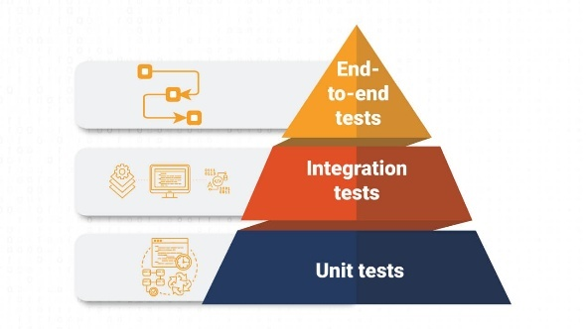
Do NOT automate:
- Rapidly changing UI
- One-time test cases
- Exploratory testing
- Usability & UX testing
- CAPTCHA / OTP flows (without backend hooks)

Interview gold line:
Automation is an investment, not a shortcut.

4️⃣ Manual Testing vs Automation Testing (Balanced View)
Manual Testing | Automation Testing
Human judgment | Scripted logic
Exploratory | Regression
Slower execution | Faster execution
Prone to human error | Consistent
Essential | Complementary

Correct mindset:
Automation supports manual testing, it does not replace it.

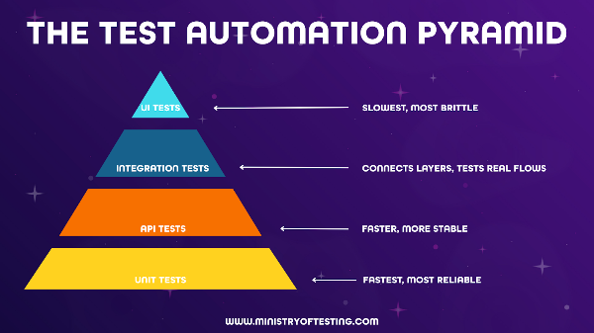
5️⃣ Where Selenium Fits in the Testing Pyramid 🧪

Testing Pyramid (Bottom → Top):
- Unit Tests (fast, cheap, many)
- API Tests
- UI Tests (Selenium) (slow, costly, fewer)

Interview expectation:
Selenium should be used sparingly, focusing on critical end-to-end user flows.

6️⃣ What is Selenium? (Precise Definition)
Selenium is an open-source browser automation framework that automates web applications by controlling real browsers.

Must mention:
- Supports multiple browsers
- Supports multiple languages (Java, Python, etc.)
- Platform independent
- Uses real browser behavior

❌ Avoid saying:
- “Selenium is a testing tool”
- “Selenium validates business logic”

7️⃣ What Selenium is NOT (Very Important)
Selenium cannot:
- Test APIs directly
- Test desktop applications
- Handle OS-level popups natively
- Replace performance testing tools
- Guarantee 100% stable tests

Senior clarity:
Selenium validates UI behavior, not backend correctness.

8️⃣ Advantages of Selenium (Interview-friendly)
- Open source (no license cost)
- Large community support
- Cross-browser support
- Language flexibility
- CI/CD friendly

9️⃣ Disadvantages of Selenium (Answer like a senior)
- Flaky tests if poorly designed
- Slow execution compared to API tests
- Requires strong framework design
- Limited handling of native OS dialogs
- Maintenance cost for unstable UI

Mature answer:
Selenium’s weaknesses are usually framework problems, not tool problems.

🔟 Should Selenium be Used for Product Development?
Correct answer: ❌ No

Why?
- Developers focus on feature delivery
- Selenium suits black-box UI validation
- Unit and integration tests are better for development

Interview-safe line:
Selenium is best suited for QA-driven validation, not feature development.

🧠 One-Line Summary for Cluster 1 (Memorize This)
Automation is a strategic investment, Selenium is a UI automation library, and its value depends entirely on where and how it is used.

CLUSTER 2: Selenium Architecture & Internals (DETAILED)
(This cluster answers: “Do you understand how Selenium actually works behind the scenes?”)

1️⃣ High-Level Selenium Architecture (Bird’s-Eye View)
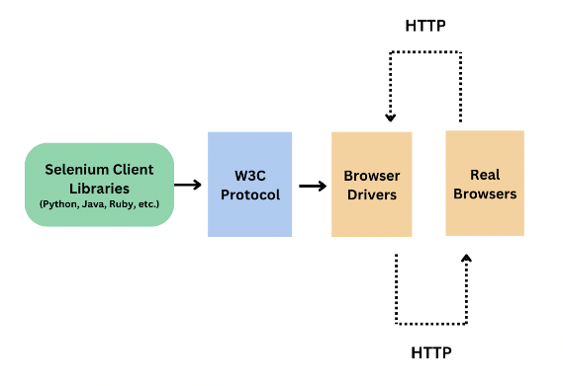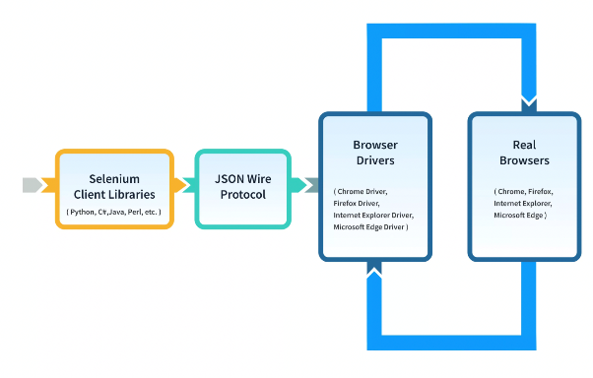

Core Idea:
Selenium follows a Client–Server architecture.

Flow (spoken interview style):
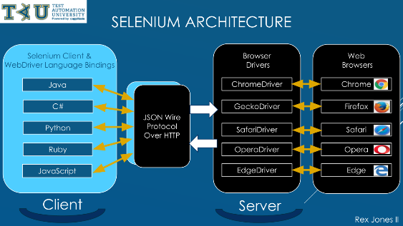
- You write Selenium code in Java (Client)
- Selenium Client Library converts code into WebDriver commands
- Commands are sent via HTTP requests
- Browser-specific driver receives the request
- Driver interacts with the real browser
- Browser sends response back to client
👉 Everything is request–response based

2️⃣ Selenium Components (Architectural, not Suite)
Interviewers often mix this up. You should not.

Selenium has:
- Selenium Client Libraries (Java, Python, etc.)
- Browser Drivers (ChromeDriver, GeckoDriver)
- WebDriver Protocol
- Browsers

Important:
Selenium itself never talks directly to the browser.
The browser driver is the translator.

3️⃣ Selenium Suite vs Selenium Architecture (Key Distinction)

Selenium Suite (What people memorize):
- Selenium IDE
- Selenium WebDriver
- Selenium Grid

Selenium Architecture (What seniors explain):
- Client libraries
- Protocol layer
- Driver executables
- Browser engine
💡 Interview maturity = knowing both and not mixing them.

4️⃣ Role of Browser Drivers (CRITICAL)

Why drivers exist:
- Each browser has a different internal implementation
- Selenium needs a common language

Examples:
- Chrome → ChromeDriver
- Firefox → GeckoDriver
- Edge → EdgeDriver

What drivers do:
- Receive HTTP commands
- Translate them into browser-native actions
- Execute actions
- Send response back

🔥 Interview trap question:
“Why can’t Selenium directly automate the browser?”
Correct reasoning:
- Browsers don’t expose automation APIs directly
- Drivers act as secure, controlled intermediaries

5️⃣ WebDriver Protocol (Where Selenium 4 Changed Everything)

Old:
- JSON Wire Protocol (Selenium 3)
- Not standardized
- Browser-specific behavior differences

New:
- W3C WebDriver Protocol (Selenium 4)
- Industry standard
- Same behavior across browsers

Interview-ready explanation:
Selenium 4 uses the W3C WebDriver protocol, which standardizes browser automation commands, reducing inconsistencies across browsers.

6️⃣ Selenium 3 vs Selenium 4 (Architecture-Level Differences)
Area | Selenium 3 | Selenium 4
Protocol | JSON Wire | W3C
Grid | Hub–Node | Distributed
Stability | Moderate | Higher
DevTools | Not supported | Supported
Setup | Manual | Simplified
🔥 You don’t need all features, but you must know why Selenium 4 exists.

7️⃣ Selenium Grid Architecture (Conceptual View)
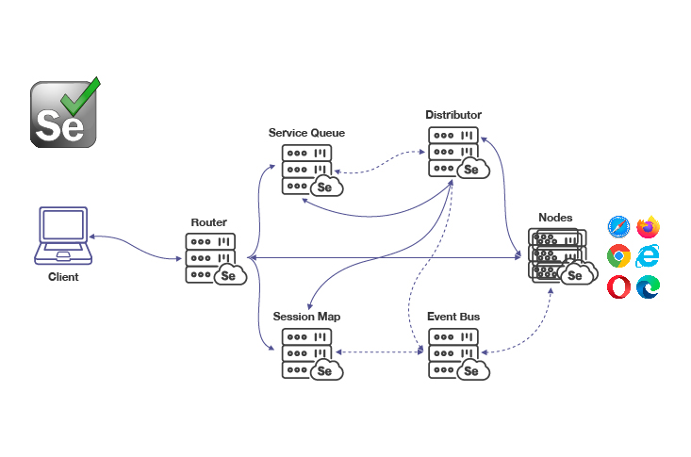
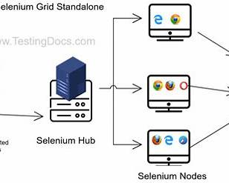

Selenium 3 Grid:
- Hub receives requests
- Nodes execute tests
- Central bottleneck

Selenium 4 Grid:
- Distributed architecture
- Event bus
- Router, Distributor, Node
- Better scalability

Interview-safe explanation:
Selenium Grid allows parallel and cross-browser execution by distributing tests across multiple environments.

8️⃣ How a WebDriver Session is Created (VERY IMPORTANT)
This is often asked indirectly.

Steps:
- new ChromeDriver() is called
- Driver executable starts
- Browser instance launches
- WebDriver session ID is created
- All commands use this session ID
- driver.quit() destroys session

Senior-level insight:
If the session is lost or corrupted, Selenium cannot recover it.

9️⃣ Why Selenium Tests Fail Randomly (Architecture Angle)
Random failures are rarely random.

Common architectural causes:
- Network latency
- Improper waits
- DOM re-rendering
- Browser-driver version mismatch
- Parallel execution conflicts

Interview-ready line:
Selenium failures usually indicate synchronization or environment issues, not Selenium bugs.

🔟 Where Selenium Architecture Ends (Boundaries)
Selenium does not handle:
- Assertions (TestNG/JUnit does)
- Test execution order
- Reporting
- Test data management
👉 Selenium is a library, not a framework.

🧠 One-Liner Summary for Cluster 2 (Memorize This)
Selenium works on a client–server model where client libraries send W3C-compliant HTTP commands to browser-specific drivers, which control real browsers and return responses.

CLUSTER 3: WebDriver & Browser Control (DETAILED)
(This cluster answers: “Do you understand how WebDriver objects, sessions, and browsers actually behave?”)

1️⃣ What is WebDriver? (Correct Mental Model)

Core truth:
WebDriver is an interface, not a class.

Why this matters:
- Promotes loose coupling
- Enables browser switching
- Supports polymorphism

Interview-ready line:
WebDriver defines a contract for browser automation, and browser-specific drivers provide the implementation.

2️⃣ Why Do We Write WebDriver driver = new ChromeDriver();

Not just syntax. This is design.

Reasons:
- Code to interface, not implementation
- Enables runtime browser selection
- Supports framework scalability

Bad answer:
“Because everyone writes it that way”

Senior answer:
It allows us to switch browsers without changing test logic.

3️⃣ Browser Driver Implementations (Behind the Scenes)
Each browser driver:
- Implements WebDriver interface
- Launches browser executable
- Listens for HTTP commands
- Maintains session lifecycle

Examples:
- ChromeDriver
- GeckoDriver
- EdgeDriver

🔥 Interview trap:
“Is ChromeDriver a class or interface?”
Correct: Class

4️⃣ WebDriver Session Lifecycle (VERY IMPORTANT)
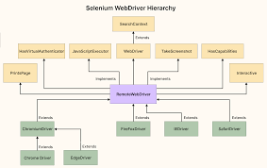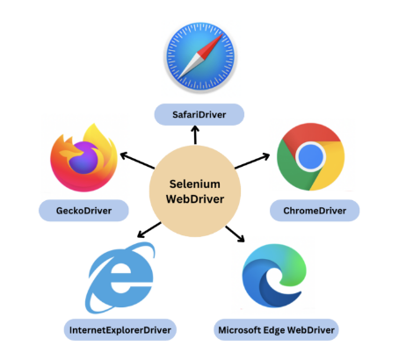

Step-by-step:
- Driver object created
- Driver server starts
- Browser instance launched
- Session ID generated
- Commands executed
- Session terminated on quit()

close() vs quit():
- close() → closes current window
- quit() → destroys entire session
🔥 Always say quit in teardown

5️⃣ Driver Initialization Best Practices

Bad practice:
WebDriver driver = new ChromeDriver();
everywhere

Good practice:
- Centralized driver factory
- Config-driven browser selection
- Single responsibility

Interview maturity:
Driver creation should be abstracted from test logic.

6️⃣ Headless Browser Execution (Conceptual)

What is headless mode?
- Browser runs without UI
- Faster execution
- Used in CI/CD

When to use:
- Regression suites
- Pipeline execution

When NOT to rely fully:
- Visual validations
- Debugging UI issues

7️⃣ Browser Capabilities & Options (High-Level)

Purpose:
- Customize browser behavior

Examples:
- Disable notifications
- Run headless
- Set download paths
- Accept insecure certificates

Interview-level clarity:
Capabilities define how a browser should behave before the session starts.

8️⃣ Handling Browser Crashes & Session Loss

Causes:
- Driver-browser mismatch
- OS resource issues
- Parallel conflicts

Expected handling:
- Proper teardown
- Retry logic at test level
- Version compatibility checks

9️⃣ Common WebDriver Misconceptions (Interview Traps)
❌ Selenium controls the browser directly
❌ WebDriver is a class
❌ One driver can control multiple browsers
❌ close() and quit() are same
✅ Drivers act as mediators
✅ One driver = one browser session

🔟 One-Line Summary for Cluster 3 (Memorize This)
WebDriver is an interface that defines browser automation behavior, while browser drivers manage session creation, command execution, and browser lifecycle.

🧠 How Interviewers Test This Cluster
They ask indirectly:
- “How do you switch browsers in your framework?”
- “What happens when new ChromeDriver() is called?”
- “Why does driver.quit() matter?”

CLUSTER 4: Locators & Element Identification Strategy (DETAILED)
(This cluster answers: “Can your automation survive UI changes?”)

1️⃣ What is a Locator? (Correct Thinking)
A locator is a strategy used by Selenium to identify a web element uniquely in the DOM.

Senior framing:
A good locator is unique, stable, readable, and change-resistant.

2️⃣ Locator Types in Selenium (Priority Order)
Locator | Priority | Reason
ID | ⭐⭐⭐⭐⭐ | Fast, unique
Name | ⭐⭐⭐⭐ | Usually stable
CSS Selector | ⭐⭐⭐⭐ | Fast, flexible
XPath | ⭐⭐⭐ | Powerful but brittle
ClassName | ⭐⭐ | Often non-unique
TagName | ⭐ | Rarely useful
LinkText / PartialLinkText | ⭐⭐ | Text-dependent

Interview-safe line:
I prefer ID and CSS selectors first, XPath only when required.

3️⃣ CSS Selector vs XPath (MOST ASKED)

CSS Selector:
- Faster
- Cleaner syntax
- Supported by browsers natively
- Cannot traverse backwards

XPath:
- Can traverse both directions
- Handles complex DOMs
- Slower
- More fragile if overused

Senior conclusion:
CSS for speed and simplicity, XPath for complex relationships.

4️⃣ Absolute vs Relative XPath (Never Defend Absolute)

Absolute XPath:
//html/body/div[2]/div[1]/form/input
❌ Breaks if UI changes

Relative XPath:
//input[@id='username']
✅ Stable and readable

Interview rule:
Absolute XPath is acceptable only for quick debugging, not automation frameworks.

5️⃣ Dynamic XPath Strategies (VERY IMPORTANT)

Using attributes:
//input[contains(@id,'user')]

Using text:
//button[text()='Login']

Using partial text:
//a[contains(text(),'Forgot')]

Combining conditions:
//input[@type='text' and @name='email']

Interview maturity:
Dynamic locators adapt to UI changes without breaking tests.

6️⃣ XPath Axes (Interview Favorites 🎯)
Used when elements lack unique attributes.
Axis | Use
parent | Move one level up
ancestor | Move multiple levels up
following-sibling | Move sideways
preceding-sibling | Reverse sibling
descendant | Downwards

Example:
//label[text()='Username']/following-sibling::input

Senior insight:
Axes should be used sparingly and only when structure is stable.

7️⃣ Handling Dynamic & Unstable DOMs

Common problems:
- Auto-generated IDs
- React/Angular re-rendering
- DOM refresh causing stale elements

Strategies:
- Use stable attributes
- Avoid index-based XPath
- Use contains() cautiously
- Re-locate elements after refresh

8️⃣ Locator Anti-Patterns (Say This in Interviews)
❌ Index-heavy XPath
❌ Overusing contains()
❌ Copy-pasting from DevTools blindly
❌ Using class names with dynamic hashes

Senior line:
Locators should describe intent, not structure.

9️⃣ Performance & Maintainability Angle

Why locators impact performance:
- Browser traversal cost
- DOM complexity
- Retry cycles due to failures

Framework best practice:
- Centralize locators in Page Objects
- One locator = one responsibility

🔟 One-Line Summary for Cluster 4 (Memorize This)
A good locator strategy prioritizes stability and intent over complexity, using ID or CSS where possible and XPath only when necessary.

🧠 How Interviewers Judge You Here
They listen for:
- Strategy over syntax
- Stability over cleverness

Advanced Locator Strategy & Real-World DOM Handling

1️⃣ How Seniors Actually Build Locators (Mental Process)
Before writing any locator, ask internally:
- Is there a unique, stable attribute?
- Will this attribute survive UI refactors?
- Is this locator readable by another engineer?
- Will this break if the page re-renders?
Locators are design decisions, not shortcuts.

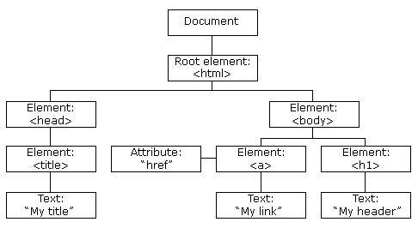
2️⃣ Reading the DOM Like a Tester (Not a Developer)
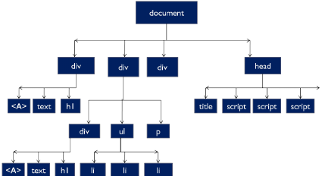

What juniors do:
- Copy XPath from DevTools
- Use index-based paths
- Ignore parent-child meaning

What seniors do:
- Identify semantic anchors (labels, aria attributes)
- Use relative positioning
- Read DOM like a tree, not a string

3️⃣ Locator Strategy for Modern Frameworks (React / Angular / Vue)

Common DOM characteristics:
- Dynamic IDs (id=react-12345)
- Frequent re-render
- Shadow-like structures
- Same components repeated

Smart strategies:
- Use data-testid, data-test, aria-label
- Use visible text as last stable anchor
- Avoid absolute parent chains

Interview-safe line:
For React applications, I prefer test-specific attributes to avoid brittle locators.

4️⃣ When XPath Index Is ACCEPTABLE (Yes, Sometimes)

Example:
(//input[@type='checkbox'])[1]

Acceptable only when:
- List order is fixed
- No unique attributes exist
- Business logic depends on order

Interview maturity:
Index-based XPath is a fallback, not a default.

5️⃣ CSS Selectors: Deeper Than Basics

Attribute matching:
input[type='email']

Partial match:
input[id^='user']
input[id$='name']
input[id*='login']

Parent-child:
form > input

Limitation reminder:
CSS cannot move upward in the DOM.

6️⃣ XPath vs CSS: Performance Reality (Interview Truth)
- Difference is negligible for most tests
- Stability matters more than speed
- Browser-native CSS is slightly faster
- Bad XPath causes maintenance, not performance issues

Senior framing:
Performance issues usually come from poor waits, not locators.

7️⃣ Debugging Broken Locators (Interview Scenario)
When a locator fails:
- Check DOM visibility
- Check iframe context
- Check dynamic re-render
- Check timing issues
- Re-validate locator in DevTools

Smart interview response:
I verify whether the element exists, is visible, and is in the correct DOM context before changing the locator.

8️⃣ Locator + Wait = Complete Strategy ⚙️
A locator alone is half the solution.
Bad:
driver.findElement(By.id("login")).click();
Good thinking:
- Wait for presence
- Wait for visibility
- Then interact
Most “locator issues” are actually synchronization issues.

9️⃣ Centralizing Locators (Framework Maturity)

Where locators should live:
- Page Object classes
- One locator per element
- No locators inside test methods

Why interviewers love this:
- Easy maintenance
- Clear responsibility
- Clean test logic

🔟 Interview Trap Questions (With Correct Angle)
Q: Is XPath slower than CSS?
➡️ Negligible difference. Stability matters more.
Q: Which locator is best?
➡️ There is no best, only most stable for the context.
Q: Do you always avoid XPath?
➡️ No. XPath is powerful when used intentionally.

🧠 Ultra-Strong One-Liner (Use This)
A locator should express business intent, not DOM structure.

✅ Cluster 4 COMPLETE CHECKLIST
You are strong if you can:
- Explain locator strategy, not just syntax
- Defend why you chose XPath or CSS
- Handle dynamic DOMs confidently
- Debug locator failures logically
- Centralize and maintain locators cleanly

CLUSTER 5: Synchronization & Wait Strategies (DETAILED)
(This cluster answers: “Why do Selenium tests fail randomly and how do you prevent it?”)

1️⃣ Why Synchronization Is Needed (Core Understanding)
Web applications are:
- Asynchronous
- Network dependent
- JavaScript-driven

Key reality:
Selenium is faster than the browser.
So Selenium tries to interact before the element is ready.

2️⃣ Types of Waits in Selenium (Clear Separation)

1️⃣ Implicit Wait
- Applied globally
- Waits for element presence
- Polls DOM until timeout
driver.manage().timeouts().implicitlyWait(Duration.ofSeconds(10));
❌ Problems:
- Affects all elements
- Conflicts with explicit waits
- Hard to debug delays

Senior rule:
Avoid implicit wait in frameworks.

2️⃣ Explicit Wait (MOST IMPORTANT)
- Applied per condition
- Waits for specific state
- Uses WebDriverWait
WebDriverWait wait = new WebDriverWait(driver, Duration.ofSeconds(10));
wait.until(ExpectedConditions.visibilityOf(element));
✅ Preferred
✅ Predictable
✅ Debuggable

3️⃣ Fluent Wait (Advanced Control)
- Custom polling interval
- Ignore specific exceptions
Wait<WebDriver> wait = new FluentWait<>(driver)
.withTimeout(Duration.ofSeconds(15))
.pollingEvery(Duration.ofSeconds(2))
.ignoring(NoSuchElementException.class);

When to use:
- Highly dynamic elements
- Slow, unpredictable pages

3️⃣ Thread.sleep() – Why Seniors Avoid It 🚫

Problems:
- Static wait
- Wastes execution time
- Breaks in slower environments
- Masks real issues

Interview-safe line:
Thread.sleep() pauses the thread, not synchronizes with the application state.

4️⃣ How Explicit Wait Actually Works (Internal View)

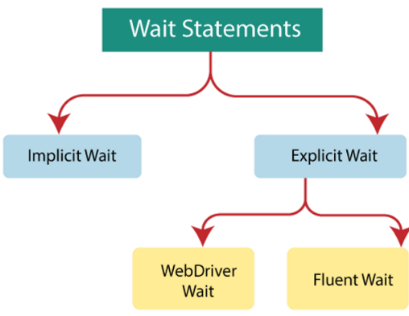
Mechanism:
- Repeated polling
- Checks condition
- Stops when condition is met or timeout occurs

Default:
- Polls every 500 ms
- Throws TimeoutException if unmet

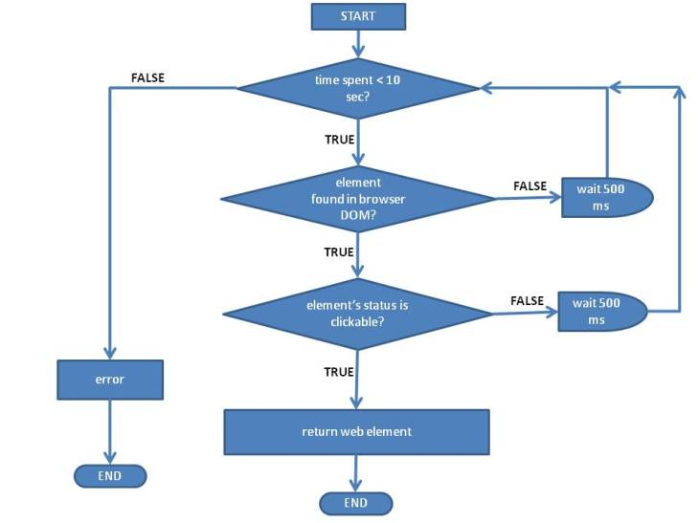
5️⃣ ExpectedConditions (You MUST Know These)
Most-used conditions:
- presenceOfElementLocated
- visibilityOf
- elementToBeClickable
- invisibilityOf
- textToBePresentInElement
- alertIsPresent
- frameToBeAvailableAndSwitchToIt

Senior insight:
Using the wrong condition is worse than no wait.

6️⃣ Presence vs Visibility vs Clickable (INTERVIEW FAVORITE)
Condition | What it checks
Presence | Element exists in DOM
Visibility | Element displayed + height/width > 0
Clickable | Visible + enabled

Trap:
Presence does NOT mean clickable.

7️⃣ StaleElementReferenceException (Wait Connection)

Why it happens:
- DOM refresh
- SPA re-render
- Page navigation

Handling strategy:
- Re-locate element
- Use wait on locator, not WebElement
- Avoid caching elements too early

8️⃣ Waits & Parallel Execution (Important for 4+ Years)

Problems:
- Shared driver instance
- Static waits block threads
- Implicit wait multiplies delays

Senior approach:
Use explicit waits with ThreadLocal WebDriver instances.

9️⃣ Common Wait Anti-Patterns (Say This Confidently)
❌ Mixing implicit + explicit waits
❌ Sleeping instead of waiting
❌ Waiting after action instead of before
❌ Using long global waits

🔟 One-Line Summary for Cluster 5 (Memorize This)
Synchronization is about waiting for application state, not time, and explicit waits are the safest way to achieve this.

🧠 Interview Trap Questions & Smart Angles
Q: Why does my test pass locally but fail in CI?
➡️ Environment speed difference + poor synchronization
Q: Can explicit wait replace Thread.sleep?
➡️ Yes, because it waits conditionally
Q: Is FluentWait better than WebDriverWait?
➡️ Only when polling control is required

✅ Cluster 5 Mastery Checklist
You are strong if you can:
- Explain WHY waits are needed
- Choose correct ExpectedCondition
- Handle stale elements
- Avoid implicit waits
- Design wait strategies for CI

Advanced Wait Scenarios & Real-World Synchronization

1️⃣ Waiting for AJAX Calls (Classic Interview Scenario)

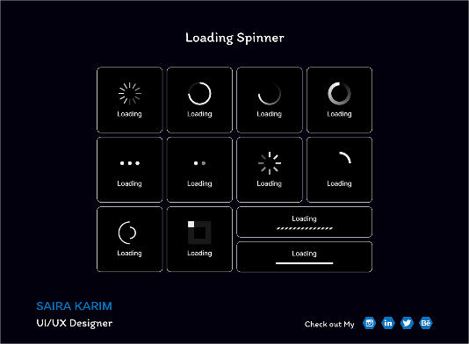
Problem:
- Page loads
- Elements appear late due to AJAX
- Selenium interacts too early

❌ Wrong thinking:
“Page is loaded, so element should be ready”

✅ Correct strategy:
- Wait for element state, not page load
- Use visibility / clickable conditions
- Avoid fixed sleeps

Senior answer line:
Page load completion does not guarantee AJAX completion.

2️⃣ Waiting for Loaders / Spinners (VERY COMMON)

Scenario:
- Spinner appears
- Blocks UI interaction
- Disappears when backend completes

Correct wait approach:
- Wait for invisibility of loader
- NOT for presence of target element

Interview-safe phrasing:
I wait for blocking overlays to disappear before interacting with elements.

3️⃣ Waiting for Page Navigation (Understood Wrongly)

Reality:
- driver.get() waits only for initial HTML
- JS may still be loading

Correct mindset:
Page load does not equal page readiness.

Better approach:
- Wait for key element of page
- Wait for URL change
- Wait for title change

4️⃣ SPA (React / Angular) Synchronization Problems

Why SPAs break Selenium:
- DOM re-renders without reload
- Elements become stale
- State changes silently

Senior strategies:
- Wait using locator-based waits, not element-based
- Re-locate elements after action
- Avoid caching WebElements

Interview gold:
In SPAs, stale elements are expected, not exceptional.

5️⃣ Handling StaleElementReferenceException (Deep)

Why retry works:
- DOM replaced old element
- New element exists with same locator

Correct handling pattern:
- Catch stale exception
- Re-find element
- Retry action (limited retries)

Senior warning:
Retrying blindly hides design problems.

6️⃣ Custom ExpectedConditions (Advanced but Valuable)

Why built-in conditions are not enough:
- Complex UI behavior
- Business-specific readiness

Conceptual explanation (no need to code fully):
Custom ExpectedConditions allow us to define application-specific wait logic.
Interviewers love hearing this even if you didn’t implement one fully.

7️⃣ Waiting Before vs Waiting After (SUBTLE BUT CRITICAL)

❌ Bad:
click();
wait();

✅ Correct:
wait();
click();

Senior line:
We wait for readiness, not for recovery.

8️⃣ Smart Polling Strategy (FluentWait Use Case)

When default polling fails:
- Backend slow
- Element appears briefly
- Transient states

FluentWait advantages:
- Custom polling interval
- Ignore specific exceptions
- Controlled retry behavior

Interview-safe:
FluentWait gives fine-grained control in unstable UI flows.

9️⃣ Waits & Timeouts Strategy (Framework Level)

Good framework practice:
- Small explicit waits (5–10 sec)
- Page-specific waits
- Avoid global waits
- Configurable timeout values

Senior thought:
Timeouts reflect business SLAs, not guesswork.

🔟 Why Tests Become Slower Over Time (Wait Perspective)

Common reasons:
- Over-increased waits
- Implicit waits everywhere
- Sleep added to “fix” flakiness

Senior answer:
Slow tests indicate fear-driven synchronization, not stability.

✅ Cluster 5 COMPLETE – ADVANCED CHECKLIST
You are interview-strong if you can:
- Handle AJAX & loaders
- Explain SPA synchronization
- Handle stale elements logically
- Avoid sleep-based fixes
- Design wait strategy per page

CLUSTER 6: WebElement & DOM Interaction (DETAILED)
(This cluster answers: “Do you understand what happens AFTER the element is found?”)

1️⃣ What is a WebElement? (Correct Mental Model)
A WebElement is a reference (pointer) to a DOM node, not the element itself.

Senior-level clarity:
Selenium does not store elements. It stores a reference to where the element was in the DOM at that moment.
This single idea explains half of Selenium exceptions.

2️⃣ findElement vs findElements (Interview Classic)
Method | Behavior
findElement | Returns first match or throws exception
findElements | Returns list (empty if none found)

Exception behavior:
- findElement → NoSuchElementException
- findElements → No exception, size = 0

Senior usage:
I use findElements when element presence is optional.

3️⃣ WebElement States (You MUST Know These)

Core states:
- Present → Exists in DOM
- Visible → Displayed on UI
- Enabled → Can be interacted with
- Selected → Checkbox / radio state

Important truth:
An element can be present but not visible or clickable.

4️⃣ Common WebElement Methods (With Intent)
Method | Purpose
click() | Triggers user click
sendKeys() | Inputs text
getText() | Visible text
getAttribute() | Attribute value
isDisplayed() | Visibility
isEnabled() | Interactable
isSelected() | Selection state

Interview maturity:
I validate element state before interacting when required.

5️⃣ NoSuchElementException (NOT Always a Locator Issue)

Happens when:
- Element not in DOM
- Wrong locator
- Element inside iframe
- Element loads late (wait issue)

Senior diagnosis order:
- Check iframe
- Check waits
- Check DOM presence
- Then check locator

6️⃣ StaleElementReferenceException (MOST IMPORTANT)

Why it happens:
- DOM refresh
- SPA re-render
- Navigation
- Page reload

Core reason:
Selenium is holding a reference to an element that no longer exists.

Senior handling:
- Re-locate element
- Avoid storing WebElements
- Use waits on locators

7️⃣ ElementNotInteractableException

Happens when:
- Element hidden
- Overlaid by another element
- Disabled
- Animation in progress

Correct response:
Wait for visibility or clickability, not presence.

8️⃣ Handling Dynamic Elements (Real-World UI)

Problems:
- Elements appear/disappear
- Lists update dynamically
- Buttons enabled after validation

Senior strategies:
- Wait for state change
- Validate size of findElements
- Avoid fixed assumptions

9️⃣ WebElement Caching (Hidden Danger ⚠️)

Bad practice:
WebElement button = driver.findElement(...);
// later reuse
button.click();

Why bad:
- DOM may change
- Leads to stale elements

Senior rule:
Cache locators, not WebElements.

🔟 DOM Interaction Best Practices (Interview Gold)
✔ Re-locate elements after navigation
✔ Use explicit waits
✔ Avoid element caching
✔ Validate state before action
✔ Handle exceptions intentionally

🧠 One-Line Summary for Cluster 6 (Memorize This)
A WebElement is a temporary reference to the DOM, and DOM changes invalidate that reference.

🎯 Interview Trap Questions & Correct Angles
Q: Why does stale element happen even when locator is correct?
➡️ Because the DOM was refreshed or re-rendered.
Q: Is isDisplayed() reliable?
➡️ Only after the element is present and located correctly.
Q: Can Selenium auto-recover from stale elements?
➡️ No. Re-location is required.

✅ Cluster 6 Mastery Checklist
You are strong if you can:
- Explain element states clearly
- Handle stale and interaction exceptions
- Distinguish locator vs wait vs DOM issues
- Avoid caching WebElements
- Debug failures logically

UI Element Interaction – Java Snippet Table
(Beginner-friendly syntax + senior-safe practices)

🧱 1️⃣ Basic Element Interactions
UI Element | Action | Java Snippet
Textbox | Enter text | driver.findElement(By.id("username")).sendKeys("admin");
Textbox | Clear & type | WebElement input = driver.findElement(By.id("email")); input.clear(); input.sendKeys("a@b.com");
Button | Click | driver.findElement(By.id("loginBtn")).click();
Label / Text | Get visible text | String msg = driver.findElement(By.id("message")).getText();

☑️ 2️⃣ Checkbox Interactions
Scenario | Snippet
Select checkbox | WebElement cb = driver.findElement(By.id("terms")); if(!cb.isSelected()) cb.click();
Unselect checkbox | if(cb.isSelected()) cb.click();
Validate selected | Assert.assertTrue(cb.isSelected());
👉 Senior note: Never blindly click checkboxes.

🔘 3️⃣ Radio Button Interactions
Scenario | Snippet
Select radio | driver.findElement(By.xpath("//input[@value='male']")).click();
Validate selected | Assert.assertTrue(driver.findElement(By.id("male")).isSelected());

📂 4️⃣ Dropdown Handling (<select>)
Action | Snippet
Select by visible text | new Select(driver.findElement(By.id("country"))).selectByVisibleText("India");
Select by value | select.selectByValue("IN");
Select by index | select.selectByIndex(2);
Get selected option | select.getFirstSelectedOption().getText();
❌ Do NOT use Select for custom dropdowns.

📜 5️⃣ Custom Dropdowns (Div / UL based)
Action | Snippet
Click dropdown | driver.findElement(By.id("dropdown")).click();
Select option | driver.findElement(By.xpath("//li[text()='Option 1']")).click();
Senior rule:
Always inspect HTML before assuming <select>.

🧾 6️⃣ Handling Lists / Multiple Elements
Scenario | Snippet
Get list size | List<WebElement> items = driver.findElements(By.cssSelector(".menu")); int size = items.size();
Click specific item | items.get(2).click();
Iterate & validate | for(WebElement e : items) { System.out.println(e.getText()); }

🚨 7️⃣ Alert Handling
Action | Snippet
Accept alert | driver.switchTo().alert().accept();
Dismiss alert | driver.switchTo().alert().dismiss();
Get alert text | driver.switchTo().alert().getText();
Send text | driver.switchTo().alert().sendKeys("Yes");

🖼️ 8️⃣ iFrame Handling
Action | Snippet
Switch by ID | driver.switchTo().frame("frame1");
Switch by index | driver.switchTo().frame(0);
Switch by element | driver.switchTo().frame(driver.findElement(By.id("frame")));
Back to main | driver.switchTo().defaultContent();
Senior reminder:
Always switch context before locating elements.

🪟 9️⃣ Multiple Windows / Tabs
Scenario | Snippet
Get parent window | String parent = driver.getWindowHandle();
Switch to child | for(String win : driver.getWindowHandles()) if(!win.equals(parent)) driver.switchTo().window(win);
Close child | driver.close(); driver.switchTo().window(parent);

🖱️ 🔟 Mouse & Keyboard Actions (Actions Class)
Action | Snippet
Hover | new Actions(driver).moveToElement(element).perform();
Right click | actions.contextClick(element).perform();
Double click | actions.doubleClick(element).perform();
Drag & drop | actions.dragAndDrop(src, dest).perform();

⌨️ 1️⃣1️⃣ Keyboard Actions
Scenario | Snippet
Press ENTER | element.sendKeys(Keys.ENTER);
CTRL + A | element.sendKeys(Keys.CONTROL + "a");
TAB | element.sendKeys(Keys.TAB);

📁 1️⃣2️⃣ File Upload
Scenario | Snippet
Upload file | driver.findElement(By.id("upload")).sendKeys("C:\\file.txt");
✔ Works only if <input type="file"> exists.

🔍 1️⃣3️⃣ Element Validation
Validation | Snippet
Is displayed | element.isDisplayed();
Is enabled | element.isEnabled();
Is selected | element.isSelected();
Attribute value | element.getAttribute("value");

🧠 1️⃣4️⃣ Safe Interaction Pattern (Recommended)
WebDriverWait wait = new WebDriverWait(driver, Duration.ofSeconds(10));
WebElement btn = wait.until(ExpectedConditions.elementToBeClickable(By.id("submit")));
btn.click();
Wait → Locate → Interact
Not the other way around.

🎯 Junior vs Senior Usage Guidance

Junior testers should:
- Learn syntax
- Use waits
- Avoid Thread.sleep

Senior testers should:
- Validate element state
- Avoid WebElement caching
- Design reusable methods
- Handle exceptions intentionally

🧠 Final One-Liner for Cluster 6
Interacting with UI elements is not about clicking fast, but about interacting at the right state and right time.

📊Web Table Handling (Static & Dynamic)

1️⃣ Identify a Web Table (Mental Model)
A typical HTML table:
<table>
<tr><th>Name</th><th>Age</th></tr>
<tr><td>John</td><td>30</td></tr>
</table>
Selenium does not have table APIs.
You interact using rows, columns, and cells.

2️⃣ Read All Rows & Columns (Basic)
List<WebElement> rows = driver.findElements(By.xpath("//table[@id='empTable']//tr"));
System.out.println("Total rows: " + rows.size());
List<WebElement> cols = driver.findElements(By.xpath("//table[@id='empTable']//tr[1]/th"));
System.out.println("Total columns: " + cols.size());

3️⃣ Read Specific Cell Value (Row–Column)
String value = driver.findElement(
By.xpath("//table[@id='empTable']//tr[2]/td[1]")
).getText();
✔ Good for static tables.

4️⃣ Dynamic Table: Find Value Based on Condition (VERY COMMON)

Example:
Get salary of employee “Arun”
List<WebElement> rows = driver.findElements(By.xpath("//table[@id='empTable']//tr"));

for(int i = 1; i < rows.size(); i++) {
String name = driver.findElement(
By.xpath("//table[@id='empTable']//tr[" + i + "]/td[1]")
).getText();

if(name.equals("Arun")) {
String salary = driver.findElement(
By.xpath("//table[@id='empTable']//tr[" + i + "]/td[3]")
).getText();
System.out.println(salary);
break;
}
}
🎯 Interview line: I locate rows dynamically and read cell data based on business conditions.

5️⃣ Click Action Inside Table Row (Edit / Delete Buttons)
driver.findElement(
By.xpath("//table[@id='empTable']//tr[td[text()='Arun']]//button[text()='Edit']")
).click();
🔥 This XPath is interview gold.

6️⃣ Handle Pagination in Tables (Conceptual)

Strategy:
- Read rows
- If not found → click next page
- Repeat
Senior framing:
Pagination handling requires looping with exit conditions, not fixed assumptions.

7️⃣ Sorting Validation in Tables (Senior-Level)
List<WebElement> values = driver.findElements(By.xpath("//table//td[2]"));
List<String> uiValues = values.stream().map(WebElement::getText).collect(Collectors.toList());

List<String> sorted = new ArrayList<>(uiValues);
Collections.sort(sorted);

Assert.assertEquals(uiValues, sorted);

📅 Calendar / Date Picker Handling

8️⃣ Calendar Types (Know This First)
Type | Example
Input-based | <input type="date">
Popup calendar | Month/Year selector
Custom JS calendar | Enterprise apps

9️⃣ Simple Input Date Picker
driver.findElement(By.id("date")).sendKeys("15-09-2026");
✔ Only if input allows typing.

🔟 Popup Calendar – Select Specific Date (MOST COMMON)

Steps:
- Open calendar
- Navigate month/year
- Select date
driver.findElement(By.id("calendar")).click();
driver.findElement(By.xpath("//span[text()='September 2026']")).click();
driver.findElement(By.xpath("//a[text()='15']")).click();

1️⃣1️⃣ Calendar – Dynamic Date Selection (Senior Pattern)
String targetDate = "15";

List<WebElement> dates = driver.findElements(By.xpath("//table[@class='ui-datepicker-calendar']//a"));

for(WebElement date : dates) {
if(date.getText().equals(targetDate)) {
date.click();
break;
}
}

1️⃣2️⃣ Navigate Calendar (Next / Previous Month)
while(!driver.findElement(By.className("ui-datepicker-title"))
.getText().equals("September 2026")) {

driver.findElement(By.xpath("//a[@title='Next']")).click();
}
✔ Used when month/year is not directly selectable.

1️⃣3️⃣ Select Today’s Date (Dynamic)
driver.findElement(By.cssSelector(".ui-datepicker-today a")).click();

1️⃣4️⃣ Calendar Validation (Senior Thinking)
String selected = driver.findElement(By.id("date")).getAttribute("value");
Assert.assertEquals(selected, "15/09/2026");

⚠️ Common Mistakes (Say This in Interviews)
❌ Hardcoding row indexes
❌ Assuming fixed table size
❌ Using Thread.sleep for calendar animation
❌ Ignoring pagination

✅ Cluster 6 – EXTENDED CHECKLIST
You’re solid if you can:
✔ Read dynamic tables
✔ Perform row-based actions
✔ Validate sorting
✔ Handle different calendar types
✔ Select dates dynamically

CLUSTER 7: Advanced User Interactions

🧠 Why This Cluster Matters
Basic clicks prove syntax.
Advanced interactions prove real project exposure.
If you handle these cleanly, interviewers assume:
- You worked on non-trivial UIs
- You debugged real production issues
- You didn’t escape to Thread.sleep() 😄

1️⃣ Actions Class – Simulating Real User Behavior (Deep Dive)
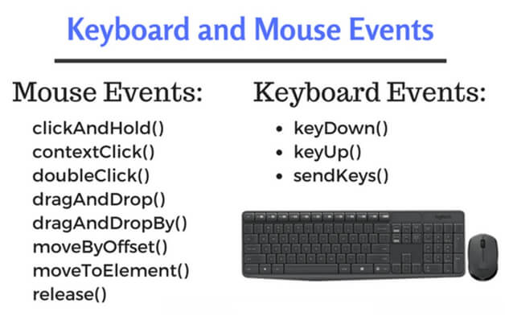

🔹 Why Actions Class Exists
click() and sendKeys() simulate simple DOM events.
Modern UIs rely on mouse movement, hover states, drag gestures, and keyboard chords.
👉 The Actions class simulates low-level user input events, closer to how humans interact.

🔹 Common Scenarios That NEED Actions
- Hover menus that reveal sub-options
- Sliders and drag-drop components
- Right-click context menus
- Keyboard shortcuts like Ctrl+A, Ctrl+S

🔹 How Actions Works Internally (Interview Insight)
- Builds a chain of actions
- Sends them as a single composite user gesture
- Browser executes them in order
That’s why you often see:
actions.moveToElement(element).click().perform();

🔹 Hover Example (Most Common)
Actions actions = new Actions(driver);
actions.moveToElement(menu).perform();
📌 Why hover fails sometimes:
- Element not visible
- Covered by overlay
- Page not scrolled
Senior fix:
Ensure visibility + scroll before hover.

🔹 Drag and Drop (Reality Check)
actions.dragAndDrop(source, target).perform();
⚠️ Many modern JS frameworks break this.
Senior workaround:
actions.clickAndHold(source)
.moveToElement(target)
.release()
.perform();
Interview gold:
Drag and drop reliability depends on how the application listens to events.

2️⃣ JavaScriptExecutor – When Selenium Is Not Enough

🔹 What JSExecutor Really Is
It allows Selenium to inject JavaScript directly into the browser.
Think of it as:
“Talking directly to the browser’s brain, bypassing the hands.”

🔹 When You SHOULD Use It
- Element is present but not clickable
- Scroll required for lazy-loaded elements
- DOM-level manipulation or inspection
Example:
JavascriptExecutor js = (JavascriptExecutor) driver;
js.executeScript("arguments[0].click();", element);

🔹 When You Should NOT Use It
- As default click strategy
- To hide synchronization issues
- To bypass business logic unintentionally
Interview-safe line:
JavaScriptExecutor is a fallback, not a replacement for WebDriver interactions.

🔹 Scrolling Use Case
js.executeScript("arguments[0].scrollIntoView(true);", element);
Used when:
- Element exists but outside viewport
- Sticky headers interfere

3️⃣ Handling JavaScript Alerts (Conceptual + Practical)

🔹 Why Alerts Are Special
Alerts are not part of the DOM.
They belong to the browser window, not the webpage.
👉 That’s why findElement() cannot see them.

🔹 Types of Alerts
- Alert – OK only
- Confirm – OK / Cancel
- Prompt – Input + OK / Cancel

🔹 Correct Handling Flow
Alert alert = driver.switchTo().alert();
alert.accept();
Other operations:
alert.dismiss();
alert.getText();
alert.sendKeys("Yes");

🔹 Senior Rule
Always wait for alert presence before switching.
Why? Switching too early causes NoAlertPresentException

4️⃣ Handling iFrames (Most Misunderstood Concept)
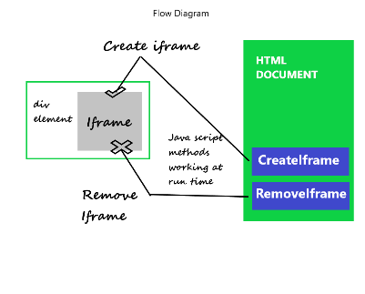

🔹 The Core Rule (Memorize This)
Selenium can interact with only one DOM context at a time.
An iframe is a separate DOM inside the main page.

🔹 Why Selenium “Cannot Find” Elements
90% of iframe issues come from:
- Forgetting to switch context
- Switching too late
- Switching back incorrectly

🔹 Ways to Switch to iframe
driver.switchTo().frame("frameId");
driver.switchTo().frame(0);
driver.switchTo().frame(frameElement);

🔹 Switching Back (Critical)
driver.switchTo().defaultContent();
Senior interview line:
Whenever an element isn’t found, iframe context is the first thing I verify.

5️⃣ Handling Multiple Windows & Tabs (Deep Understanding)

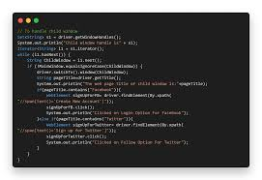

🔹 Why Windows Are Tricky
- Selenium does NOT auto-switch windows
- Every window has a unique handle
- Index-based switching is unreliable

🔹 Correct Mental Model
Selenium talks to one window at a time, identified by a handle.

🔹 Correct Handling Pattern
String parent = driver.getWindowHandle();

for(String win : driver.getWindowHandles()) {
if(!win.equals(parent)) {
driver.switchTo().window(win);
break;
}
}

🔹 Closing Child Window Safely
driver.close();
driver.switchTo().window(parent);
Interview maturity:
Window handling should always be handle-based, never index-based.

6️⃣ File Upload & File Download (Real-World Handling)

🔹 File Upload – What Selenium CAN Do
Selenium can upload files only when:
- HTML uses <input type="file">
- The element is not hidden by OS dialog
driver.findElement(By.id("upload"))
.sendKeys("C:\\files\\resume.pdf");

Why this works:
- Selenium bypasses OS dialog
- Browser sets file path internally

🔹 File Upload – What Selenium CANNOT Do
❌ Cannot handle:
- Native OS file chooser popups
- Drag-drop file upload without input tag

Senior solutions:
- Ask dev team for <input type="file">
- Use API or backend upload
- Use Robot/AutoIT (last resort)
Interview-safe line:
Selenium interacts with browser DOM, not operating system dialogs.

🔹 File Download – Correct Automation Strategy
Selenium cannot click “Save” on OS dialogs.

Correct approach:
- Configure browser to auto-download
- Set custom download directory
- Validate file existence via Java
Example (Conceptual):
// Set ChromeOptions with download directory
Validation:
File file = new File("C:\\downloads\\report.pdf");
Assert.assertTrue(file.exists());
Senior note:
File download validation belongs to Java, not Selenium.

7️⃣ Scrolling & Lazy-Loaded Content

🔹 Why Scrolling Matters
Modern apps:
- Load content on scroll
- Hide elements outside viewport
- Use infinite scrolling
Selenium does not auto-scroll.

🔹 Scrolling Techniques
Scroll by pixels:
js.executeScript("window.scrollBy(0,500);");
Scroll to element:
js.executeScript("arguments[0].scrollIntoView(true);", element);
Scroll to bottom:
js.executeScript("window.scrollTo(0, document.body.scrollHeight);");

Senior caution:
Scrolling should support visibility, not replace waits.

8️⃣ Click Intercepted, Overlays & Animations

🔹 Common Exception
ElementClickInterceptedException

Happens when:
- Loader overlays UI
- Animation still running
- Sticky headers block click
- Element partially visible

🔹 Correct Debug Strategy
- Check for loader overlay
- Wait for invisibility
- Scroll element into view
- Use JS click only as last fallback
Example:
wait.until(ExpectedConditions.invisibilityOf(loader));
button.click();
Senior interview line:
Click interception is a UI readiness issue, not a locator issue.

9️⃣ Complex User Flows (End-to-End Reliability)

🔹 What Makes a Flow “Complex”?
- Multiple page transitions
- Mixed interactions (hover, click, type)
- Context switches (iframe, window)
- Dynamic waits

🔹 Example Flow Breakdown
Scenario:
- Hover menu
- Click sub-menu
- Switch iframe
- Fill form
- Upload file
- Handle alert
- Switch window
- Validate success
Senior thinking: Each step must verify readiness before proceeding.

🔹 How Seniors Design Complex Flows
✔ Break flow into reusable methods
✔ Validate after each major step
✔ Handle failures gracefully
✔ Log intermediate states

🔴 What Interviewers Watch For (Silent Evaluation)
They listen for:
- State awareness
- Context switching discipline
- Controlled use of JSExecutor
- Avoidance of sleeps
- Recovery strategies

🧠 Killer One-Liners for Concepts 6–9
- “Selenium interacts with browsers, not OS dialogs.”
- “Scrolling supports visibility; it doesn’t replace synchronization.”
- “Click interception is usually caused by overlays or animations.”
- “Complex flows succeed only when each step validates state.”

✅ Cluster 7 COMPLETE – FINAL CHECKLIST
You’re interview-strong if you can:
✔ Handle file uploads/downloads correctly
✔ Scroll reliably for dynamic content
✔ Resolve click intercepted issues cleanly
✔ Design stable complex user flows
✔ Explain limitations confidently

CLUSTER 8: Page Object Model (POM) & Framework Design
(This cluster answers: “Can you build automation that survives 6 months?”)

1️⃣ Why Page Object Model Exists (THE WHY)

The real problem POM solves:
- Duplicate locators
- Unmaintainable tests
- UI change chaos
- Tight coupling between tests and UI

Without POM:
driver.findElement(By.id("username")).sendKeys("admin");
driver.findElement(By.id("password")).sendKeys("pwd");
driver.findElement(By.id("login")).click();
(locators everywhere ☠️)

With POM:
UI knowledge lives in pages, test logic lives in tests.

2️⃣ What Is Page Object Model? (Correct Definition)
Page Object Model is a design pattern where each page of the application is represented as a class, exposing actions as methods and hiding locators.

Interview-safe phrasing:
Tests interact with behavior, not elements.

3️⃣ Anatomy of a Page Object (Core Structure)
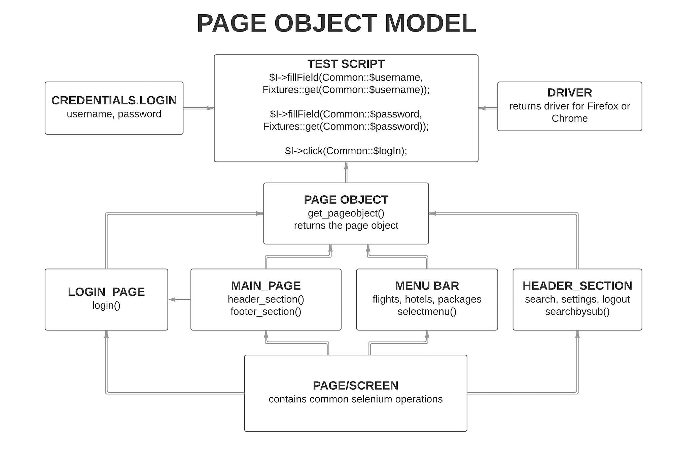
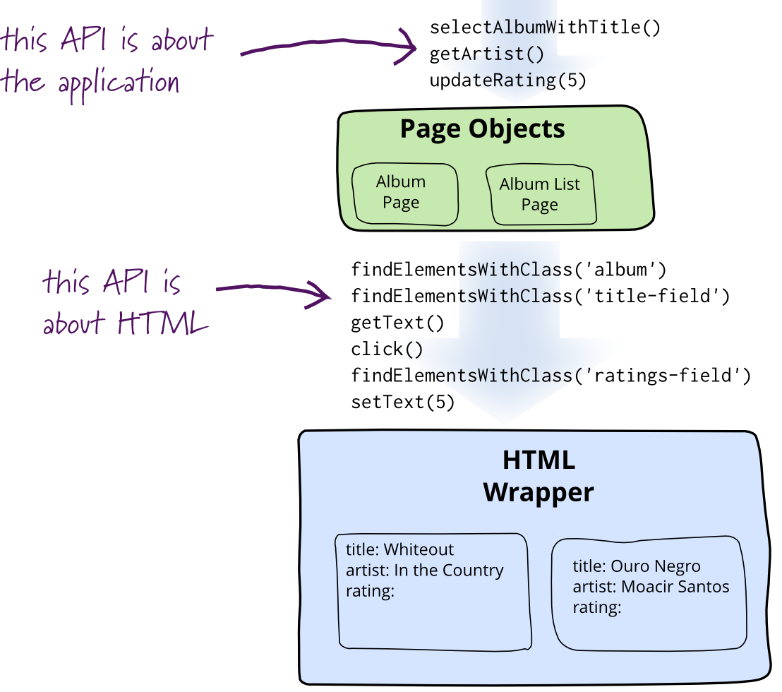

A good Page Object contains:
- Private locators
- Public action methods
- Page-level validations
- No test assertions

4️⃣ Simple POM Example (Login Page)

Page Class
public class LoginPage {

private WebDriver driver;

private By username = By.id("username");
private By password = By.id("password");
private By loginBtn = By.id("login");

public LoginPage(WebDriver driver) {
this.driver = driver;
}

public void login(String user, String pass) {
driver.findElement(username).sendKeys(user);
driver.findElement(password).sendKeys(pass);
driver.findElement(loginBtn).click();
}
}

Test Class
LoginPage login = new LoginPage(driver);
login.login("admin", "pwd");
🎯 Tests read like business flows.

5️⃣ Page Object vs Page Factory (INTERVIEW FAVORITE)
Page Object | Page Factory
Manual By locators | @FindBy annotations
Explicit control | Lazy initialization
Preferred in modern frameworks | Less flexible

Senior answer:
PageFactory hides waits and causes stale element issues in dynamic apps.

6️⃣ Where Assertions Should Live (VERY IMPORTANT)

❌ Bad Practice:
Assertions inside Page classes

✅ Correct Practice:
Assertions in Test classes
Why?
- Pages describe behavior
- Tests verify outcomes
Interview line:
Pages should not know about test validation logic.

7️⃣ Handling Waits in POM (Design Maturity)

❌ Bad:
Waits inside test methods

✅ Good:
- Central wait utility
- Page-level synchronization
- Reusable explicit wait methods
Senior insight:
Synchronization is a framework concern, not test logic.

8️⃣ Reusability & Maintainability (How Seniors Think)

Strategies:
- One responsibility per page
- No test data in pages
- Avoid chaining unrelated pages
- Meaningful method names
Example:
dashboardPage.navigateToReports();
not:
clickReportsIcon();

9️⃣ POM Anti-Patterns (Interview Red Flags 🚩)
❌ Hard-coded waits in pages
❌ Assertions in page classes
❌ Huge God pages
❌ Direct driver.findElement in tests
❌ Page objects returning WebElements

🔟 Framework Layers (Big Picture)
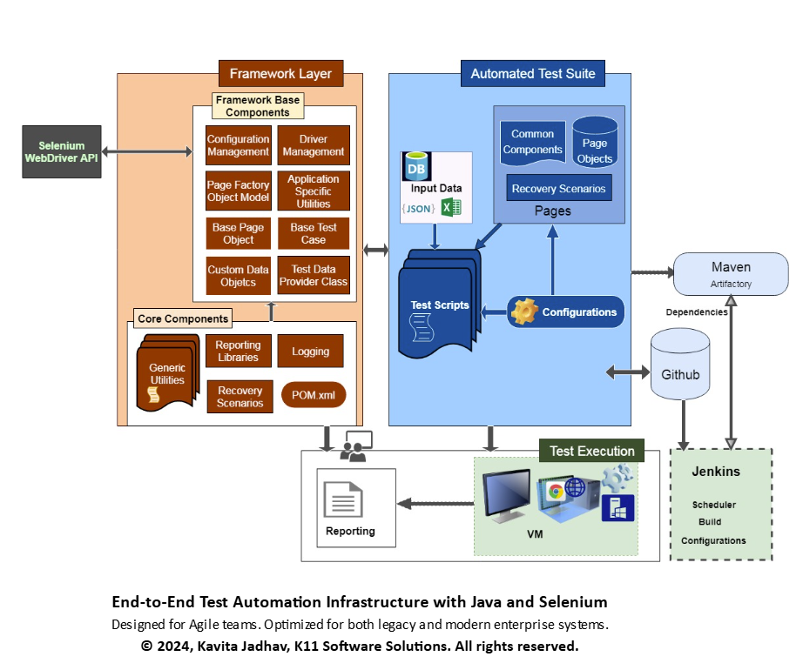
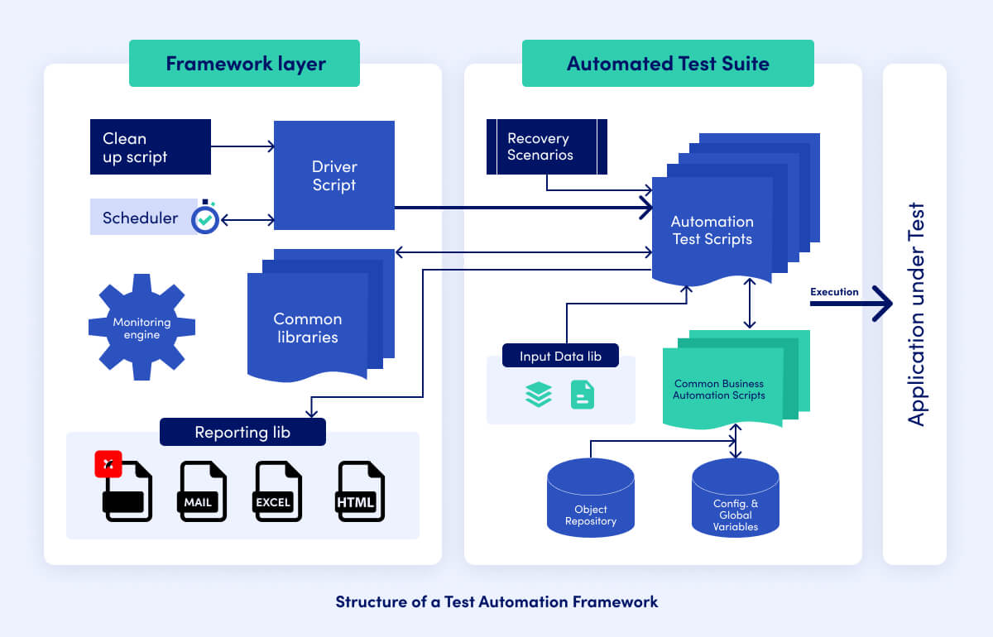
Typical layers:
- Test layer
- Page layer
- Utility layer
- Config layer
- Reporting layer
Interview-safe:
POM is part of the framework, not the framework itself.

🧠 One-Line Summary for Cluster 8 (Memorize This)
Page Object Model separates UI knowledge from test logic, making automation maintainable and scalable.

✅ Cluster 8 Mastery Checklist
You’re strong if you can:
✔ Explain WHY POM exists
✔ Design clean page classes
✔ Keep assertions out of pages
✔ Handle waits at page/framework level
✔ Avoid common POM anti-patterns

CLUSTER 9: TestNG with Selenium (DETAILED)
(This cluster answers: “Can you control execution, not just write tests?”)

1️⃣ What is TestNG? (Correct Framing)
TestNG is a testing framework that:
- Controls test execution
- Manages test lifecycle
- Provides assertions, grouping, parallelism, reporting hooks

Interview-safe definition:
TestNG is a test execution and orchestration framework that integrates with Selenium to manage test flow and validation.
❌ Selenium alone cannot do this.

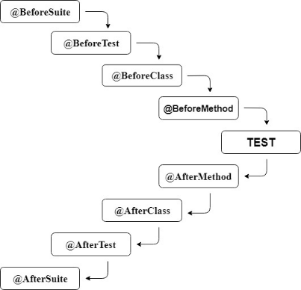
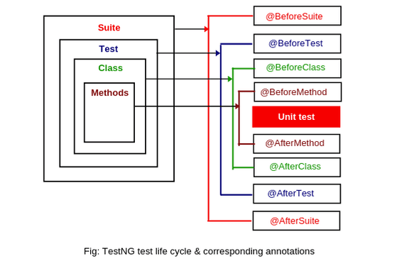
2️⃣ TestNG Execution Lifecycle (VERY IMPORTANT)

Order of execution (top → bottom):
- @BeforeSuite
- @BeforeTest
- @BeforeClass
- @BeforeMethod
- @Test
- @AfterMethod
- @AfterClass
- @AfterTest
- @AfterSuite

Senior mental model:
- Suite → whole run
- Test → logical grouping (XML)
- Class → test class
- Method → individual test

3️⃣ Where Things SHOULD Live (Interview Favorite)
Annotation | Responsibility
@BeforeSuite | Report setup, config load
@BeforeTest | Browser config
@BeforeClass | Page object init
@BeforeMethod | Driver setup, login
@AfterMethod | Screenshot on failure, quit
@AfterSuite | Report flush
Senior line: WebDriver lifecycle is best managed at method level for isolation.

4️⃣ @Test Annotation Deep Dive
@Test(
priority = 1,
description = "Verify valid login",
enabled = true
)
public void loginTest() {}

Attributes you should know:
- priority
- enabled
- dependsOnMethods
- groups
- invocationCount
Senior warning: Overusing priority is a code smell.

5️⃣ Assertions in TestNG (Hard vs Soft)

Hard Assertion
Assert.assertEquals(actual, expected);
- Fails immediately
- Stops test

Soft Assertion
SoftAssert sa = new SoftAssert();
sa.assertTrue(condition);
sa.assertAll();
- Collects failures
- Reports at end
Senior usage: Soft assertions are used when multiple validations are independent.

6️⃣ TestNG XML (Execution Controller)
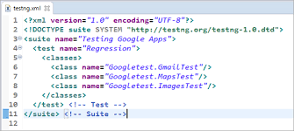
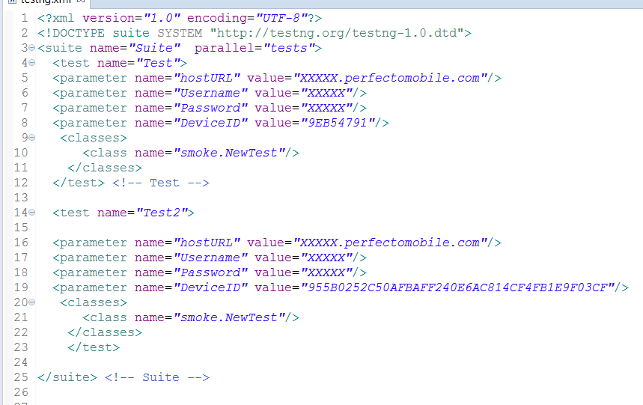

Sample XML:
<suite name="RegressionSuite" parallel="tests" thread-count="3">
<test name="LoginTests">
<classes>
<class name="tests.LoginTest"/>
</classes>
</test>
</suite>

Why XML matters:
- Environment control
- Parallel execution
- Selective test runs
- CI integration

7️⃣ Grouping Tests (REAL PROJECT USAGE)
@Test(groups = {"smoke"})
public void smokeTest() {}
XML:
<groups>
<run>
<include name="smoke"/>
</run>
</groups>
Senior insight: Groups reflect business priority, not technical grouping.

8️⃣ Data-Driven Testing (DataProvider)
@DataProvider
public Object[][] loginData() {
return new Object[][] {
{"admin", "pass"},
{"user", "wrong"}
};
}
@Test(dataProvider = "loginData")
public void loginTest(String user, String pass) {}
Senior note: DataProviders should be light; heavy data belongs outside code.

9️⃣ Retry Logic (Controlled Use)
@RetryAnalyzer(RetryAnalyzer.class)
@Test
public void flakyTest() {}
Senior warning: Retry hides instability if misused.

🔟 Parallel Execution (INTRODUCTION LEVEL)
Mode | Meaning
methods | Parallel methods
classes | Parallel classes
tests | Parallel <test> blocks
Senior MUST: ThreadLocal WebDriver is mandatory for parallel execution.

🧠 Common Interview Trap Questions
Q: Can Selenium run tests without TestNG?
➡️ Yes, but no lifecycle, reporting, or assertions.
Q: Where should driver.quit() be called?
➡️ In @AfterMethod for clean isolation.
Q: Is TestNG mandatory?
➡️ No, but required for scalable automation.

🧠 Killer One-Liners (Use These)
- “TestNG controls execution; Selenium controls the browser.”
- “Annotations define responsibility, not convenience.”
- “Parallel execution without thread safety is dangerous.”
- “Assertions belong in tests, not pages.”

✅ Cluster 9 Mastery Checklist
You’re strong if you can:
✔ Explain annotation lifecycle
✔ Use TestNG XML confidently
✔ Handle assertions correctly
✔ Design data-driven tests
✔ Run tests in parallel safely

CLUSTER 10: Parallel Execution & Thread Safety
(Advanced • Highly Valued • Senior Filter)

1️⃣ Why Parallel Execution Is Needed (THE WHY)

The real-world problem:
- UI tests are slow
- Regression suites grow endlessly
- CI pipelines become bottlenecks

Example:
- 200 UI tests × 30 seconds = ~100 minutes
- Parallel (5 threads) = ~20 minutes

Senior framing:
Parallel execution reduces feedback time, not test count.

Where it’s MOST useful:
- Regression suites
- Cross-browser testing
- CI/CD pipelines
- Nightly builds

2️⃣ What “Parallel Execution” Actually Means
Parallel execution means:
- Multiple test threads
- Each thread has its own browser session
- Tests run simultaneously, not sequentially
⚠️ Important:
One browser = one thread = one WebDriver instance

3️⃣ TestNG Parallel Modes (INTERVIEW FAVORITE)
TestNG controls parallelism via testng.xml.

🔹 Parallel Modes Explained
Mode | Meaning | Use Case
methods | Test methods run in parallel | Small, independent tests
classes | Classes run in parallel | Page-based isolation
tests | <test> blocks run in parallel | Cross-browser, environments

🔹 XML Examples

Parallel by methods
<suite name="Suite" parallel="methods" thread-count="3">

Parallel by classes
<suite name="Suite" parallel="classes" thread-count="2">

Parallel by tests (MOST STABLE)
<suite name="Suite" parallel="tests" thread-count="2">

Senior preference:
parallel="tests" is the safest and most predictable.

4️⃣ The Core Problem: Shared WebDriver 💥

❌ What juniors often do:
public static WebDriver driver;

What happens in parallel:
- Thread A opens Chrome
- Thread B overwrites driver
- Tests click on wrong browser
- Random failures, screenshots from wrong test 😬

Senior truth:
Selenium is thread-safe. Your framework usually isn’t.

5️⃣ ThreadLocal WebDriver (THE SOLUTION)

🔹 What is ThreadLocal?
ThreadLocal stores one value per thread, not globally.
Think of it as:
“Each thread gets its own locker.”

🔹 Correct ThreadLocal Implementation (Interview-Ready)
public class DriverFactory {

private static ThreadLocal<WebDriver> driver = new ThreadLocal<>();

public static void setDriver(WebDriver driverInstance) {
driver.set(driverInstance);
}

public static WebDriver getDriver() {
return driver.get();
}

public static void quitDriver() {
driver.get().quit();
driver.remove();
}
}
Usage:
DriverFactory.getDriver().findElement(...);

Senior line:
ThreadLocal guarantees one WebDriver per test thread.

6️⃣ WebDriver Lifecycle in Parallel Execution

Best Practice:
- Create driver in @BeforeMethod
- Quit driver in @AfterMethod
Why?
- Test isolation
- No cross-test pollution
- Safe retries

Senior framing:
Parallel execution without isolation is chaos with confidence.

7️⃣ Common Parallel Execution Issues (REAL PROJECT PAIN)

🔴 Issue 1: Random test failures
Cause: Shared driver, shared waits
Fix: ThreadLocal + explicit waits

🔴 Issue 2: Wrong screenshots attached
Cause: Screenshot method uses static driver
Fix: Always use DriverFactory.getDriver()

🔴 Issue 3: Tests pass locally, fail in CI
Cause: Lower resources, race conditions
Fix: Reduce threads, improve waits

🔴 Issue 4: Browser closes mid-test
Cause: One thread quits driver used by another
Fix: Never share driver

8️⃣ Thread Safety Beyond WebDriver (Often Missed)

Thread-unsafe items:
- Static variables
- Shared test data
- Singleton utilities
- ExtentReports instances

Correct approach:
- Thread-safe reporting
- Thread-aware logging
- Avoid mutable statics
Senior line:
WebDriver isn’t the only thing that needs thread safety.

9️⃣ Classic Thread Safety Mistakes (INTERVIEW RED FLAGS 🚩)
❌ Static WebDriver
❌ Driver created in @BeforeClass
❌ Parallel + implicit waits
❌ Shared page object instances
❌ Retry without isolation

🔟 When NOT to Use Parallel Execution
Parallel execution is NOT ideal when:
- Tests depend on shared data
- Environment is unstable
- Application has session limits
- Debugging is priority
Senior honesty:
Parallelism amplifies problems if foundations are weak.

🧠 Killer Interview One-Liners (USE THESE)
- “Parallel execution reduces feedback time, not complexity.”
- “One thread, one driver, one test.”
- “ThreadLocal is mandatory, not optional.”
- “Parallel execution exposes framework weaknesses.”

✅ Cluster 10 Mastery Checklist
You’re senior-ready if you can:
✔ Explain why parallel execution is needed
✔ Choose correct TestNG parallel mode
✔ Implement ThreadLocal WebDriver
✔ Debug parallel failures logically
✔ Avoid thread safety anti-patterns

CLUSTER 11: Selenium Grid & Cross-Browser Testing
(Scalability • Distributed Execution • CI/CD Ready)

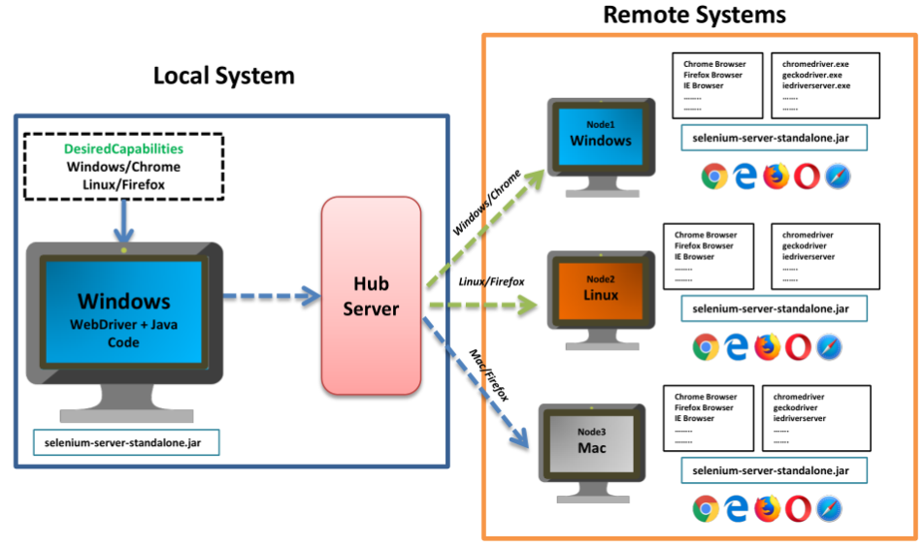

1️⃣ Why Selenium Grid Is Needed (THE WHY)

The real-world problem:
- Applications must work on:
  - Chrome, Firefox, Edge
  - Different OS combinations
- Running browsers one-by-one is too slow
- CI pipelines need distributed execution

Without Grid:
- One machine
- One browser
- Long execution time

With Grid:
- Multiple machines (or containers)
- Multiple browsers
- Parallel + cross-browser execution

Senior framing:
Selenium Grid enables scalable, distributed, cross-browser test execution.

2️⃣ What Selenium Grid Actually Does
Selenium Grid allows you to:
- Run tests on remote machines
- Execute tests in parallel
- Control execution centrally
- Simulate real-user environments
⚠️ Important:
Grid does NOT make tests faster individually, it makes the suite finish sooner.

3️⃣ Selenium Grid Architecture (Selenium 4)

Selenium 4 moved away from Hub–Node bottleneck.

Core components now:
Component | Responsibility
Router | Entry point for test requests
Distributor | Assigns tests to nodes
Node | Runs browser sessions
Event Bus | Communication backbone

Interview-safe line:
Selenium Grid 4 uses a distributed architecture instead of a single hub-node model.

4️⃣ Selenium 3 vs Selenium 4 Grid (INTERVIEW FAVORITE)
Feature | Selenium 3 | Selenium 4
Architecture | Hub–Node | Distributed
Bottleneck | Hub | Reduced
Setup | Complex | Simplified
Stability | Moderate | Improved
DevTools | ❌ | ✅
Senior clarity:
Selenium 4 Grid is more scalable and fault-tolerant.

5️⃣ Local Execution vs Remote Execution

Local:
WebDriver driver = new ChromeDriver();

Remote (Grid):
WebDriver driver = new RemoteWebDriver(
new URL("http://localhost:4444"),
options
);

Key difference:
- Commands go over HTTP
- Browser runs on another machine
Senior insight:
RemoteWebDriver behaves like WebDriver, but execution happens elsewhere.

6️⃣ DesiredCapabilities vs Options (Modern View)

Old way:
DesiredCapabilities caps = new DesiredCapabilities();
caps.setBrowserName("chrome");

Modern way (Preferred):
ChromeOptions options = new ChromeOptions();
options.setPlatformName("WINDOWS");
Senior line:
Capabilities define browser intent before session creation.

7️⃣ Cross-Browser Testing Strategy (IMPORTANT)

❌ Wrong approach:
- Same test blindly on all browsers
- No prioritization

✅ Correct strategy:
- Smoke tests on all browsers
- Full regression on primary browser
- Risk-based browser selection
Senior thinking:
Cross-browser testing is about confidence, not coverage vanity.

8️⃣ Grid + Parallel Execution (How They Work Together)
- TestNG controls threads
- Grid controls browser distribution
- ThreadLocal ensures driver safety
Flow:
TestNG Thread → RemoteWebDriver → Grid → Node → Browser
Senior line:
Parallel execution decides “how many”; Grid decides “where”.

9️⃣ Common Selenium Grid Issues (REAL PROJECT)

🔴 Issue 1: Session not created
Cause: Browser version mismatch
Fix: Align browser & driver versions

🔴 Issue 2: Tests hang randomly
Cause: Node overload
Fix: Reduce thread count

🔴 Issue 3: Slow execution
Cause: Network latency
Fix: Run Grid closer to CI agents

🔴 Issue 4: Browser crashes
Cause: Resource exhaustion
Fix: Increase node resources

🔟 When Selenium Grid Should NOT Be Used
Grid is NOT ideal when:
- Application is unstable
- Tests are flaky
- Environment is limited
- Debugging individual tests
Senior honesty:
Grid amplifies instability if test design is weak.

🧠 Interview Trap Questions & Smart Answers
Q: Is Selenium Grid mandatory for parallel execution?
➡️ No. Parallel execution can be local. Grid is for distributed execution.
Q: Can one node run multiple browsers?
➡️ Yes, depending on configuration and resources.
Q: Does Grid improve test stability?
➡️ No. It improves scalability, not stability.

🧠 Killer One-Liners (USE THESE)
- “Grid distributes execution; TestNG controls concurrency.”
- “Grid reduces execution time, not test complexity.”
- “Cross-browser testing should be risk-based.”
- “RemoteWebDriver behaves the same, executes elsewhere.”

✅ Cluster 11 Mastery Checklist
You’re interview-strong if you can:
✔ Explain Grid purpose clearly
✔ Describe Selenium 4 Grid architecture
✔ Use RemoteWebDriver correctly
✔ Design cross-browser strategies
✔ Debug Grid-related failures

🔄 End-to-End Selenium Execution Flow

Local → Parallel → Grid (Conceptual + Practical)

🟢 STAGE 1: Local Execution (Foundation)

🧠 What “Local Execution” Means
- Tests run one by one
- On your machine
- One browser at a time
- Mostly for:
  - Development
  - Debugging
  - Script creation

🔧 Execution Flow (Local)
Test Method
↓
WebDriver (ChromeDriver)
↓
Local Browser

Example:
WebDriver driver = new ChromeDriver();
driver.get("https://app");

✅ Pros
- Easy to debug
- Simple setup
- Good for beginners

❌ Cons
- Slow for large suites
- No scalability
- No cross-browser confidence

🧠 Interview Insight
Local execution validates correctness, not scalability.

🟡 STAGE 2: Parallel Execution (Speed Upgrade)

🧠 What Changes Here
- Tests still run locally
- But multiple tests run at the same time
- Each test gets its own browser

🔧 Execution Flow (Parallel – Local)
TestNG Thread 1 → WebDriver 1 → Browser 1
TestNG Thread 2 → WebDriver 2 → Browser 2
TestNG Thread 3 → WebDriver 3 → Browser 3

🔑 Key Enablers
- TestNG parallel mode
- ThreadLocal<WebDriver>
- Method-level driver lifecycle

XML Example:
<suite name="Suite" parallel="tests" thread-count="3">

✅ Pros
- Faster execution
- Better CI feedback
- Still simple infra

❌ Cons
- Limited by local machine resources
- Still single OS
- Browser crashes under load

🧠 Interview Insight
Parallel execution improves speed, but not environment coverage.

🔴 STAGE 3: Selenium Grid Execution (Scale & Reach)

🧠 What Changes Here
- Tests run from one machine
- Browsers run on many machines
- Execution is distributed

🔧 Execution Flow (Grid)
TestNG Thread
↓
RemoteWebDriver
↓
Selenium Grid Router
↓
Distributor
↓
Available Node
↓
Browser (Chrome / Firefox / Edge)

Code Difference (Key Moment)

Local:
new ChromeDriver();

Grid:
new RemoteWebDriver(
new URL("http://grid:4444"),
options
);

✅ Pros
- Cross-browser testing
- Cross-OS testing
- Massive scalability
- CI/CD friendly

❌ Cons
- Network latency
- Setup complexity
- Harder debugging

🧠 Interview Insight
Grid doesn’t make tests better, it makes coverage broader.

🧩 Putting All 3 Together (BIG PICTURE)
Stage | Speed | Scale | Complexity | Purpose
Local | ❌ | ❌ | ⭐ | Development
Parallel | ✅ | ❌ | ⭐⭐ | Fast feedback
Grid | ✅ | ✅ | ⭐⭐⭐⭐ | Enterprise CI

🧠 The MOST IMPORTANT UNIFYING CONCEPT
Regardless of stage:
One Test Thread
= One WebDriver
= One Browser Session
This rule never changes.

🔥 Common Interview Trap (And Correct Answer)
Q: Do I need Selenium Grid for parallel execution?
➡️ No. Parallel execution can be local. Grid is for distributed execution.
Q: Does Grid replace TestNG parallel?
➡️ No. TestNG controls threads. Grid controls where browsers run.

🧠 Senior-Level One-Liners (Memorize These)
- “Parallel decides how many, Grid decides where.”
- “Local is for correctness, Grid is for confidence.”
- “Grid scales execution, not test quality.”
- “ThreadLocal is mandatory across all three stages.”

✅ Final Mastery Check
You’re interview-ready if you can:
✔ Explain evolution clearly
✔ Draw this flow on a whiteboard
✔ Differentiate parallel vs grid
✔ Explain RemoteWebDriver role
✔ Defend when Grid is NOT needed

CLUSTER 12: Java Essentials for Selenium Automation
(Must-know for 4+ years • Interview-critical)
Interviewers don’t expect you to be a Java developer,
but they do expect you to write clean, safe, scalable automation code.

1️⃣ OOP Concepts (Automation-Oriented, Not Theory)

🔹 Encapsulation (MOST USED)
What it means in automation:
- Hide locators
- Expose behavior
private By loginBtn = By.id("login");

public void clickLogin() {
click(loginBtn);
}
🎯 Interview line:
Encapsulation protects tests from UI changes.

🔹 Inheritance
Used for:
- BasePage
- BaseTest
- Shared utilities
public class LoginPage extends BasePage
⚠️ Senior warning:
Inheritance should reduce duplication, not create deep hierarchies.

🔹 Polymorphism (VERY IMPORTANT)
Seen in:
WebDriver driver = new ChromeDriver();
Why?
- Runtime flexibility
- Browser switching
- Loose coupling
Interview gold:
Polymorphism allows framework-level decisions without changing test logic.

🔹 Abstraction
Used when:
- Defining contracts
- Multiple implementations
Example:
public interface Browser {
WebDriver launch();
}

2️⃣ Exception Handling (REAL-WORLD USAGE)

🔹 Why Exception Handling Matters in Automation
- UI is unstable
- Network is unpredictable
- Selenium throws runtime exceptions

🔹 Common Selenium Exceptions You Must Know
- NoSuchElementException
- TimeoutException
- StaleElementReferenceException
- ElementClickInterceptedException

🔹 Proper Use of try-catch (Senior Rule)
❌ Bad:
try { click(); } catch(Exception e) {}
✅ Good:
try {
click();
} catch (TimeoutException e) {
takeScreenshot();
throw e;
}
Interview line:
We should not hide failures; we should enrich them.

3️⃣ Collections Framework (VERY FREQUENTLY ASKED)

🔹 Why Collections Matter in Selenium
- Web tables
- Lists of elements
- Dropdowns
- API responses

🔹 List (MOST USED)
List<WebElement> elements = driver.findElements(By.cssSelector(".item"));
Used for:
- Iteration
- Size validation
- Searching text

🔹 Set
Used for:
- Window handles
- Unique values
Set<String> windows = driver.getWindowHandles();

🔹 Map (Senior-Level Usage)
Used for:
- Test data
- Key-value mappings
Map<String, String> user = new HashMap<>();
user.put("username", "admin");
Interview line:
Maps help manage structured test data cleanly.

4️⃣ Java 8 Features (Automation-Relevant Only)

🔹 Lambda Expressions
Used to:
- Simplify loops
- Cleaner waits
- Readable code
elements.forEach(e -> System.out.println(e.getText()));

🔹 Streams (COMMON IN INTERVIEWS)
List<String> texts = elements.stream()
.map(WebElement::getText)
.collect(Collectors.toList());
Used for:
- Filtering table data
- Sorting validations
Senior line:
Streams improve readability, not just brevity.

🔹 Functional Interfaces
Examples:
- Predicate
- Function
- Consumer
Interview-safe:
Selenium’s waits internally use functional interfaces.

🔹 Optional (Awareness Level)
Used to:
- Avoid NullPointerException
- Defensive programming

5️⃣ Multithreading Basics (Automation Context)

🔹 Why You Need It
- Parallel execution
- ThreadLocal WebDriver
- CI pipelines

🔹 What You MUST Understand
- Threads ≠ processes
- Shared memory risks
- Static variables are dangerous
Interview line:
ThreadLocal ensures isolation in parallel Selenium execution.

6️⃣ String Handling (Often Ignored, Often Asked)

🔹 Why Strings Matter
- UI validations
- Messages
- Logs
- Assertions

Common methods:
equals()
contains()
trim()
split()
substring()
Interview trap:
Always use equals(), not ==, for String comparison.

7️⃣ File Handling & Properties (Framework Essentials)

🔹 Why Needed
- Environment config
- URLs
- Credentials
- Browser choice
Properties prop = new Properties();
prop.load(new FileInputStream("config.properties"));
Senior line:
Config must be externalized, not hard-coded.

8️⃣ Static vs Instance (VERY IMPORTANT)

🔹 Static (Shared)
- Constants
- Utility methods

🔹 Instance (Per object)
- Page classes
- Driver references
❌ Static WebDriver
✅ Instance + ThreadLocal
Interview line:
Static state breaks parallel execution.

9️⃣ Memory & Performance Awareness (Bonus)
You don’t need JVM internals, but you should know:
- Object creation cost
- Garbage collection impact
- Avoid unnecessary object creation in loops
Senior insight:
Poor Java design amplifies Selenium instability.

🧠 Killer One-Liners for Cluster 12
- “Automation frameworks are Java applications with Selenium libraries.”
- “Clean Java reduces flaky Selenium behavior.”
- “Thread safety is a Java problem before it’s a Selenium problem.”
- “Encapsulation is the backbone of POM.”

✅ Cluster 12 Mastery Checklist
You’re interview-strong if you can:
✔ Explain OOP with automation examples
✔ Handle Selenium exceptions cleanly
✔ Use Collections confidently
✔ Explain Java 8 usage in Selenium
✔ Understand multithreading basics

